A

Project Report

On

**“E-Commerce Website”**

Submitted in partial fulfillment of

the requirements for the 5th Semester Sessional Examination of

BACHELOR OF TECHNOLOGY

IN

**COMPUTER SCIENCE & ENGINEERING**

By

**K VEER SUMAN RAO**

**Registration No.-1801210202**



**DEPARTMENT OF COMPUTER SCIENCE & ENGINEERING**

**GIET MAIN CAMPUS AUTONOMOUS**

**GUNUPUR – 765022**

**2020 - 21**

**GIET MAIN CAMPUS AUTONOMOUS,**

**GUNUPUR-765022, Dist: Rayagada (Orissa), India**

**(Approved by AICTE and Govt, of Orissa)**

**Ph: 06857 – 250172(Office), 251156(Principal), 250232(Fax),**

**E-mail:** [**gandhi_giet@yahoo.com**](mailto:gandhi_giet@yahoo.com) **visit us at WWW.giet.org**

**Department of Computer Science & Engineering**



**CERTIFICATE**

This is to certify that the project work entitled “**E-COMMERCE WEBSITE**” is done by **Name- K VEER SUMAN RAO, Regd. No. - 1801210202** in partial fulfillment of the requirements for the 5th Semester Sessional Examination of Bachelor of Technology in Computer Science and Engineering during the academic year 2020-21. This work is submitted to the department as a part of evaluation of 5th Semester Project.

Mrs.Gitanjali Mishra

Class Teacher Prof. (Dr). Sanjay Kumar Kuanar

HoD, CSE

**ACKNOWLEDGEMENT**

My journey to this point has been a good one and through it all, I have had some people who have been there for me through it all. I would like to thank my HOD Mr. Sanjay Kuanar who have been of great help to me. I would like to thank my class teacher Mrs.Gitanjali Mishra for helping me to finish my project finally. She has been instrumental in my report process, and I appreciate that very much.

GANDHI INSTITUTE OF ENGINEERING AND TECHNOLOGY

AUTONOMOUS, GUNUPUR

Computer Science

**ABSTRACT**

Author K VEER SUMAN RAO

Title an E-Commerce shopping website

The year 2021

Language English

Pages 44

The thesis aimed to develop an online shop using open source technologies (JAVA, HTML5, CSS3, JavaScript, MySQL and Apache Web Server) for electronics products in India where customers will be able to buy products online. The designed application will have an admin view and the public or guest view. The admin view is meant for the administrator to update the products, change prices, remove and add products and also manage customers. The customer view will be accessible to the customers, and they will be able to handle their information such as their name, address, and contact. Also, the customer will be able to order for products from the shop.

## INTRODUCTION

E-commerce (electronic commerce or EC) is the buying and selling of goods and services, or the transmitting of funds or data, over an electronic network, primarily the internet. These business transactions occur either as business-to-business, business-to-consumer, consumer-to-consumer or consumer-to-business.

E-commerce shops have become part of our daily lives. Technological advancement has made it possible for people to sit in the convenience of their homes and still shop online without going to a physical shop. Africans have also joined the trend of e-commerce business, so this project is meant to design an eCommerce online shop so that the people in Ghana (Africa)will be able to purchase their goods and services online.

This project is mainly divided into two main categories: The Administrators and the Customers/Users.

The store manager and the staff members operate as the administrators. They can add, edit, update products or, delete products thus they able to change the names of products, change prices and, add or remove products.

The customer can search for products selection, update the cart, remove products from the cart and check out from the shop. The customer is also able to update his information such as names, address and other data.

The User is only able to browse the online shop and add a product to the cart. The user is limited to the use of the shop.

* 1. **Purpose-**

Essentially, an ecommerce website is one that allows a business to function almost entirely online, supplanting the need for a home office equipped with a sales and managerial staff. The process is automatic, and this is what makes it stand apart from other sites that still have business development as the main goal.

* 1. **Project Scope-**

All transactions would be handled electronically or online – e-commerce facilitates all the various shopping-related activities, including the purchase and sales of goods and services, shipping, billing, etc. online.

The scope of eCommerce Business in India is undoubtedly going to increase year after year. A recent report by the Internet and Mobile Association of India shows that a fast-paced growth of around 50% is to be expected in the coming five years.

The primary attribute of this growth is undoubtedly the rise of 3G/4G mobile internet users and a large number of smartphone users because the same mobile commerce is expected to change how business transactions happen in India.

The scope of eCommerce business is turning out to be more famous day-after-day according to the market demand. And this requirement is generating innovations worldwide focused on delivery time, ease of transactions and several features served by eCommerce businesses, for example, drone delivery or artificial intelligence.

## SYSTEM ANALYSIS

* 1. **User Requirements (SRS)-**
* Functionality
* Usability
* Reliability and Availability
* Performance
* Supportability
* Design Constraint
* Interfaces
  1. **Hardware Requirements-**
* CPU: for web 1,6 GHz , for web and database 4 x 1,6 GHz CPU.
* RAM: 4GB.
* Minimum database space: 10GB.
* CPU: Quad 2GHz+ CPU.
* RAM: 6GB.
* Minimum database space: 10GB.

## SYSTEM DESIGN AND SPECIFICATIONS-

## In this phase, a logical system is built which fulfils the given requirements. Design phase of software development deals with transforming the customer’s requirements into a logically working system. Normally, design is performed in the following two steps:

* Primary Design Phase: In this phase, the system is designed at block level. The blocks are created on the basis of analysis done in the problem identification phase. Different blocks are created for different functions emphasis is put on minimising the information flow between blocks. Thus, all activities which require more interaction are kept in one block.
* Secondary Design Phase: In the secondary phase the detailed design of every block is performed.
  1. High Level Design (HLD)-
     1. Data Flow Diagram-

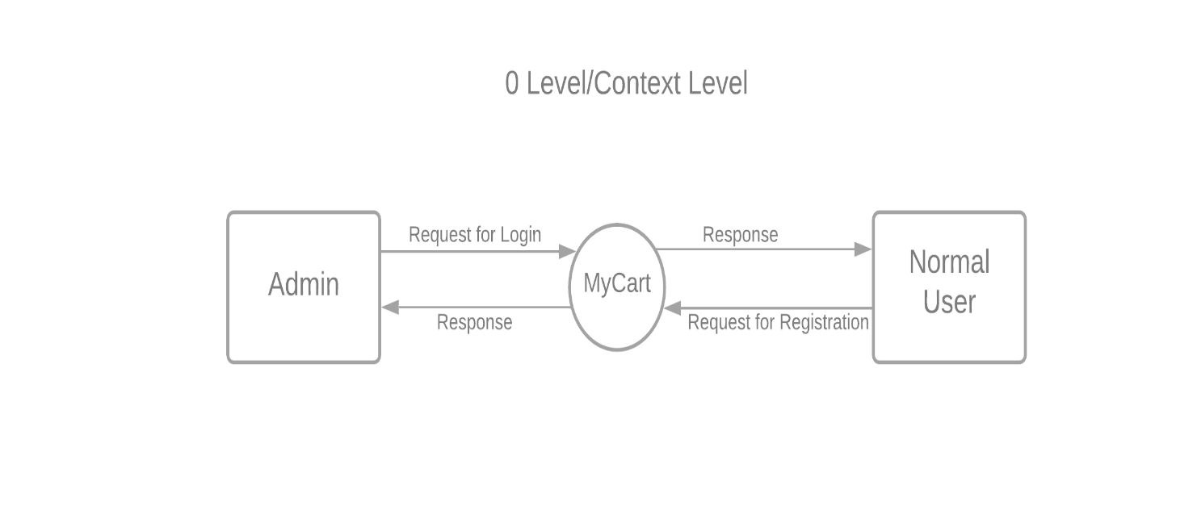

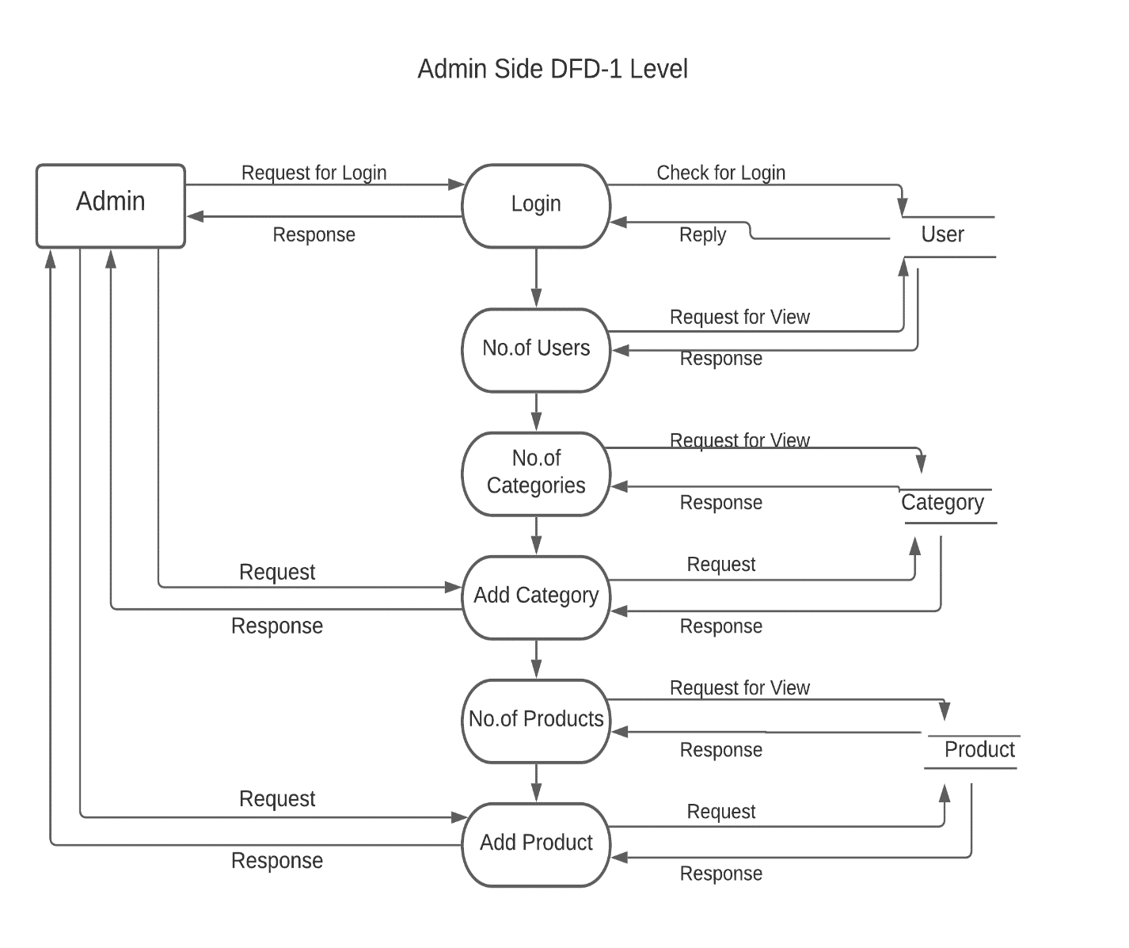

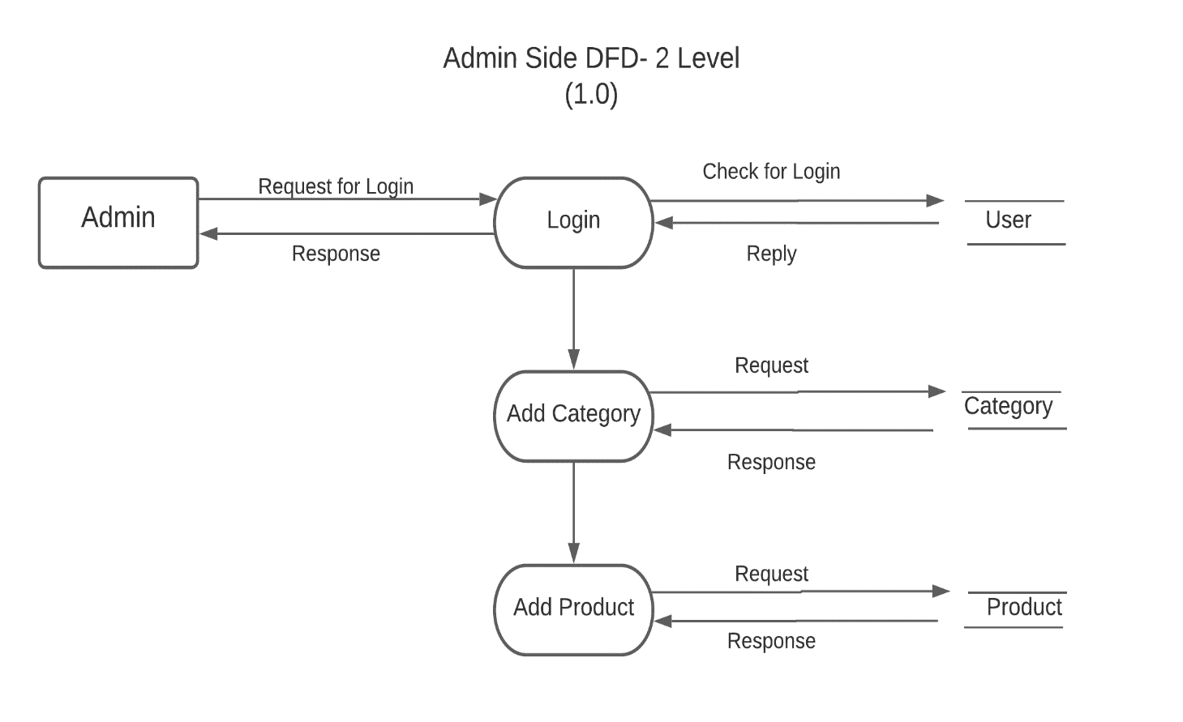

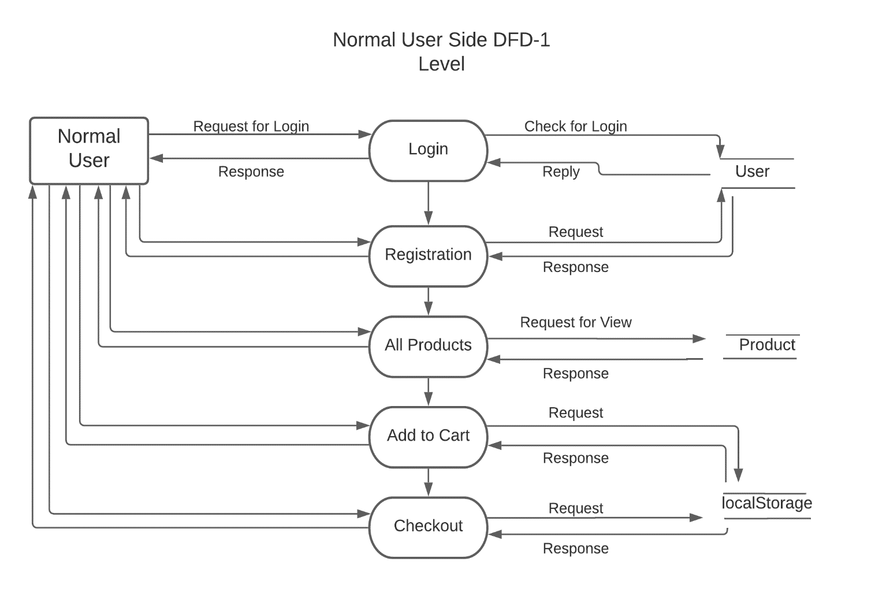

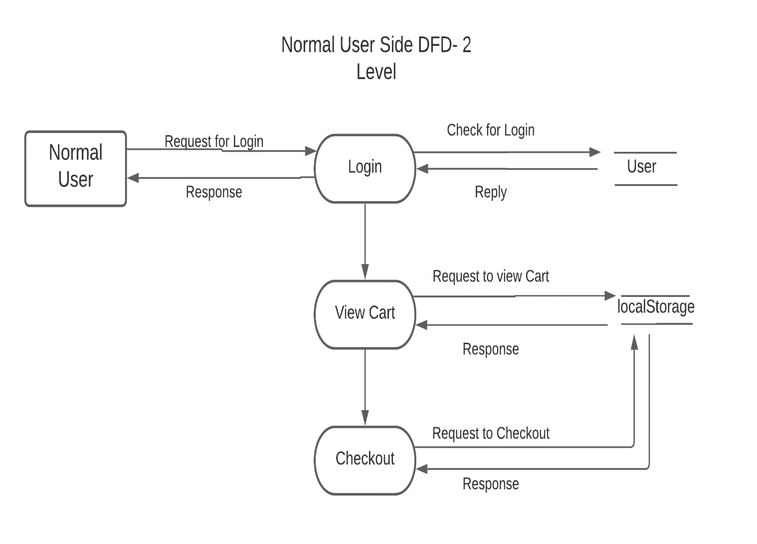

* + 1. **E-R Diagram-**

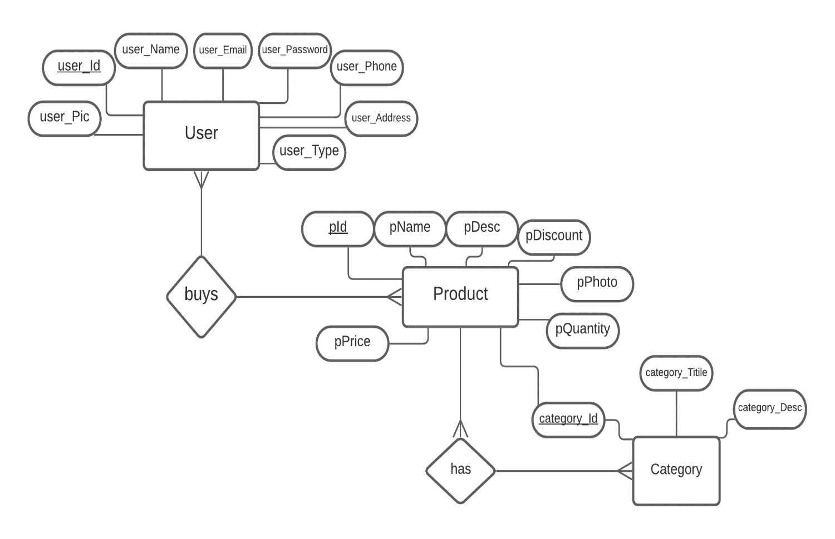

* + 1. **Use Case Diagram-**

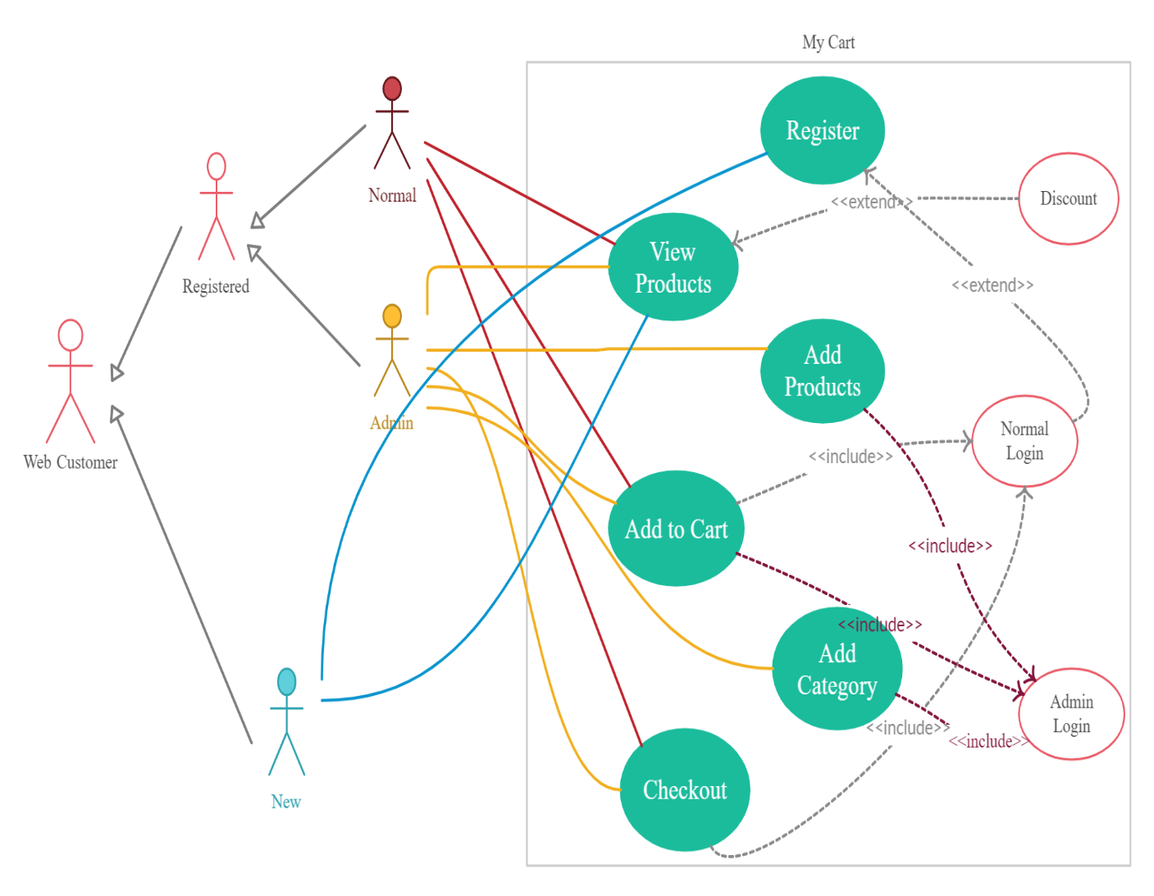

* 1. Low Level Design (LLD)-
     1. **Screen-Shot-**

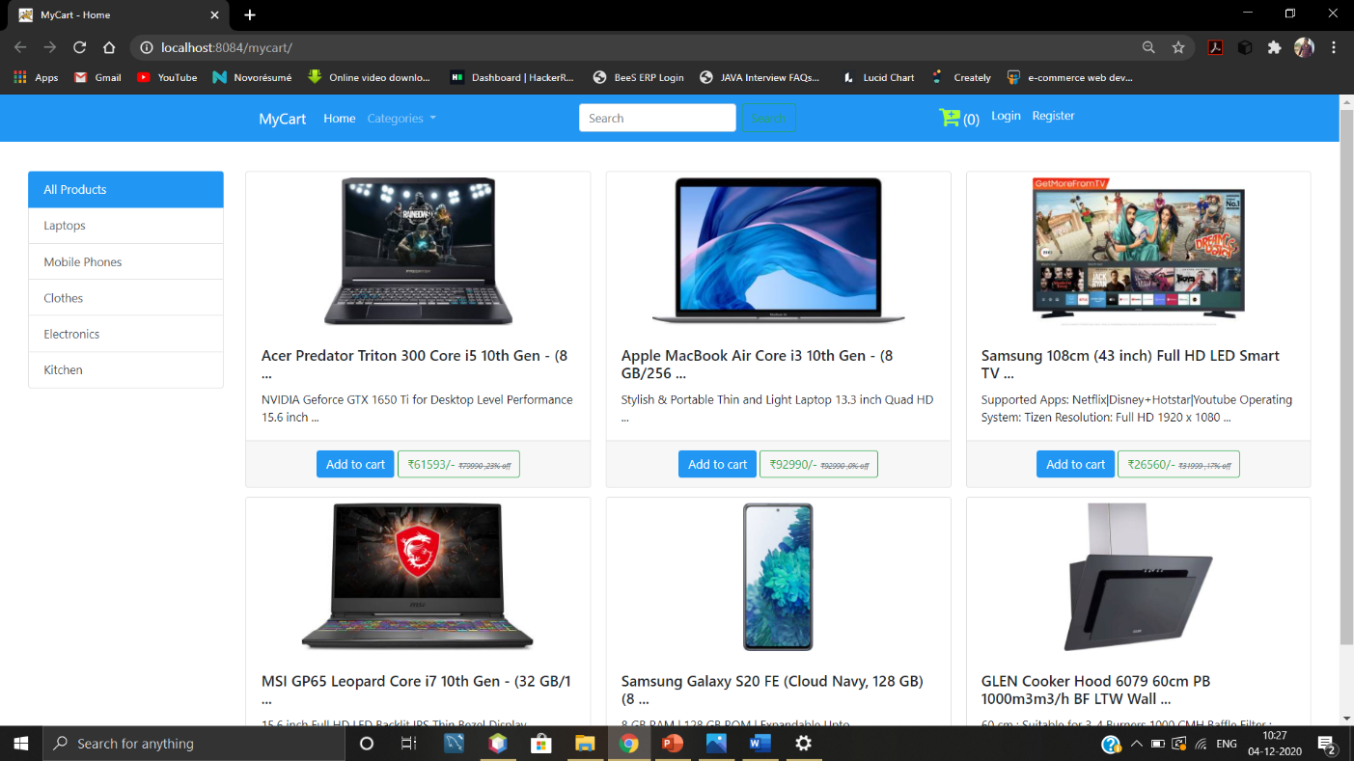

Figure 1. Homepage of Website

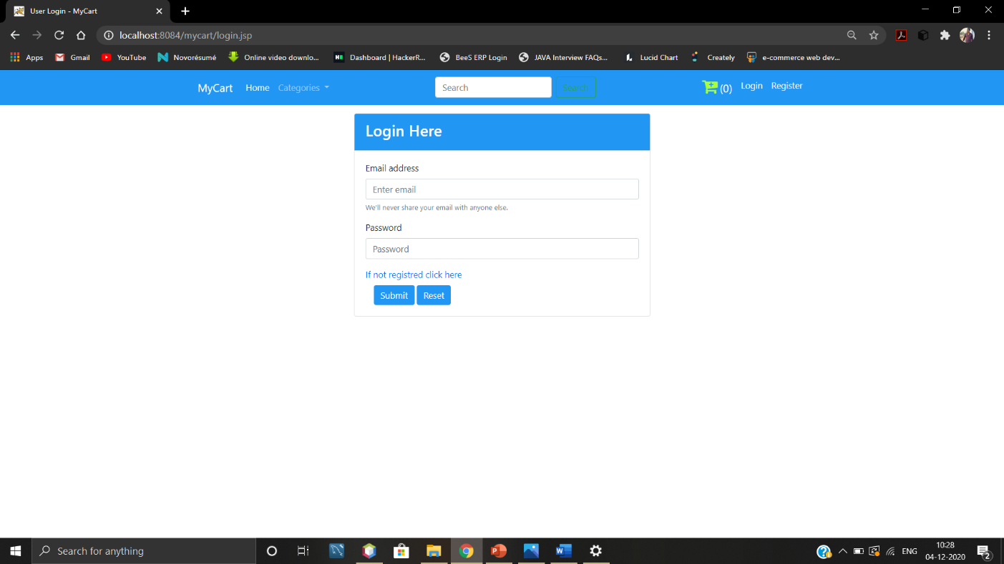

Figure 2. Login Page

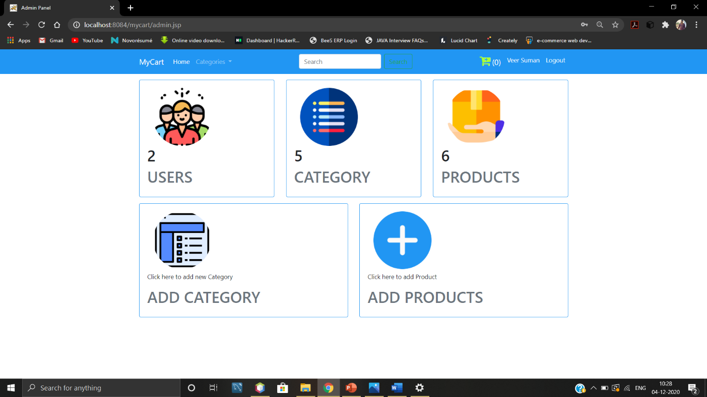

Figure 3. Admin View Page

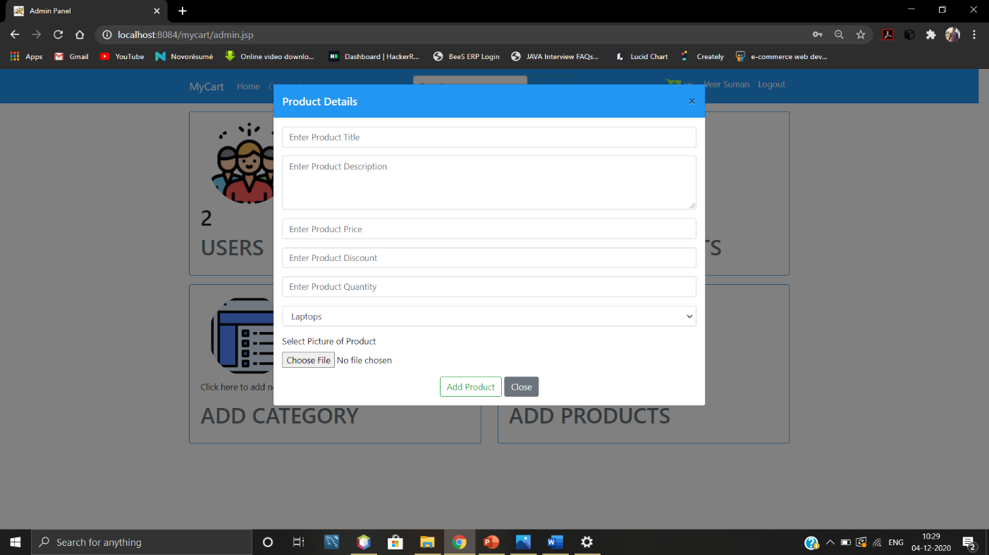

Figure 4. Add Products Pop-Up

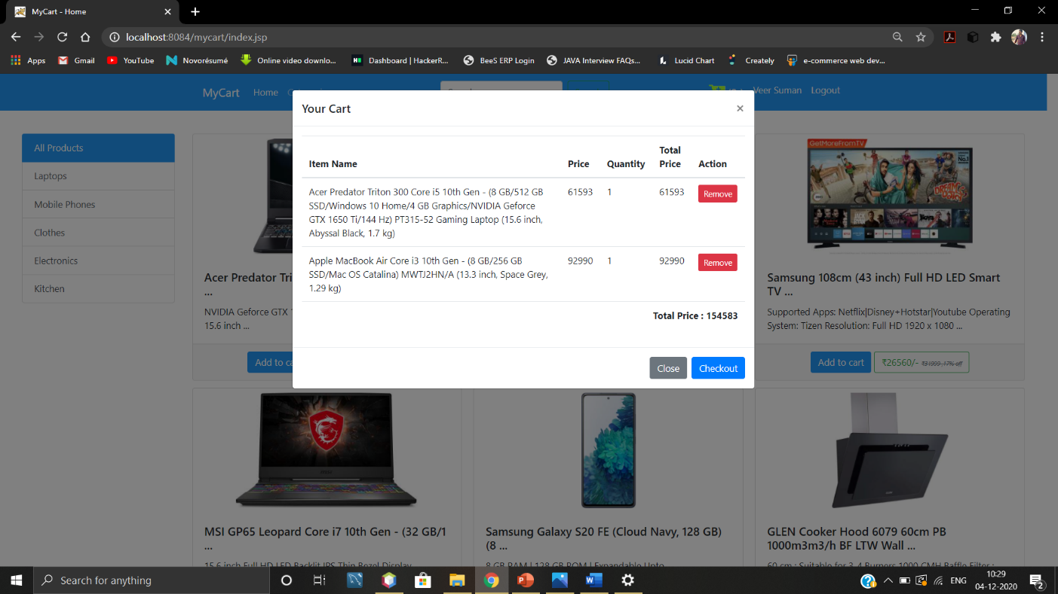

Figure 5. Cart

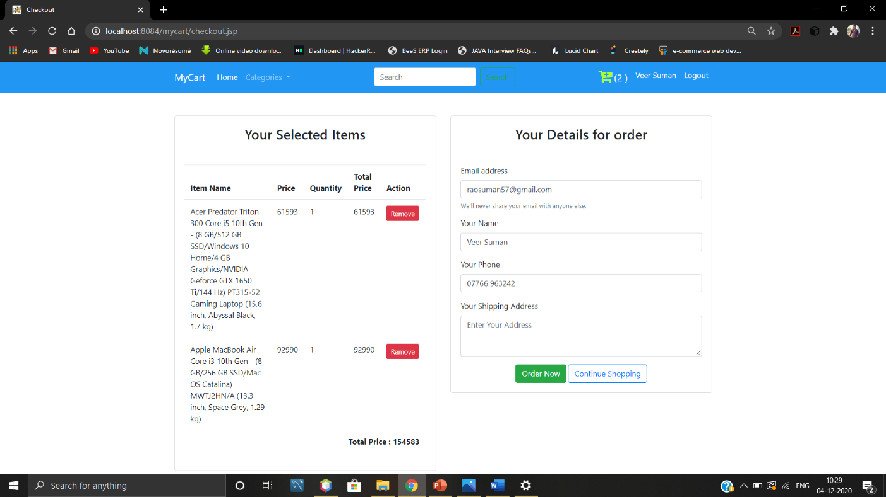

Figure 6. Checkout Page

1. **CODING**
   1. **About-**

<%@page contentType="text/html" pageEncoding="UTF-8"%>

<!DOCTYPE html>

<html>

<head>

<meta http-equiv="Content-Type" content="text/html; charset=UTF-8">

<title>JSP Page</title>

</head>

<body>

<%@include file="components/navbar.jsp" %>

<h1>About Page</h1>

<%@include file="components/common_css_js.jsp" %>

</body>

</html>

* 1. **Admin**

<%@page import="java.util.Map"%>

<%@page import="com.learn.mycart.helper.Helper"%>

<%@page import="java.util.List"%>

<%@page import="com.learn.mycart.helper.FactoryProvider"%>

<%@page import="com.learn.mycart.dao.CategoryDao"%>

<%@page import="com.learn.mycart.entities.User"%>

<%@page import ="com.learn.mycart.entities.Category"%>

<%

User user = (User) session.getAttribute("current-user");

if (user == null) {

session.setAttribute("message", "You are not logged in !! Login first");

response.sendRedirect("login.jsp");

return;

} else {

if (user.getUserType().equals("normal")) {

session.setAttribute("message", "You are not Admin!! Do not access this page");

response.sendRedirect("login.jsp");

return;

}

}

%>

<% CategoryDao cdao = new CategoryDao(FactoryProvider.getFactory());

List<Category> list = cdao.getCategories();

//getting count

Map<String,Long> m = Helper.getCounts(FactoryProvider.getFactory());

%>

<%@page contentType="text/html" pageEncoding="UTF-8"%>

<!DOCTYPE html>

<html>

<head>

<meta http-equiv="Content-Type" content="text/html; charset=UTF-8">

<title>Admin Panel</title>

<%@include file="components/common_css_js.jsp" %>

</head>

<body>

<%@include file="components/navbar.jsp" %>

<div class="container admin">

<div class="container-fluid mt-3">

<%@include file="components/message.jsp" %>

</div>

<div class="row mt-3">

<!--first col-->

<div class="col-md-4">

<div class="card">

<div class="card-body text-centre">

<div class="container">

<img style="max-width: 150px; " class="img-fluid rounded-circle" src="img/user.png" alt=""user_icon">

</div>

<h1><%=m.get("userCount") %></h1>

<h1 class="text-uppercase text-muted">Users</h1>

</div>

</div>

</div>

<!--second col-->

<div class="col-md-4">

<div class="card">

<div class="card-body text-centre">

<div class="container">

<img style="max-width: 150px; " class="img-fluid rounded-circle" src="img/list.png" alt=""user_icon">

</div>

<h1><%=list.size() %></h1>

<h1 class="text-uppercase text-muted">Category</h1>

</div>

</div>

</div>

<!--third col-->

<div class="col-md-4">

<div class="card">

<div class="card-body text-centre">

<div class="container">

<img style="max-width: 150px; " class="img-fluid rounded-circle" src="img/product.png" alt=""user_icon">

</div>

<h1><%=m.get("productCount") %></h1>

<h1 class="text-uppercase text-muted">Products</h1>

</div>

</div>

</div>

</div>

<!--second row-->

<div class="row mt-3">

<!--second row first col-->

<div class="col-md-6">

<div class="card" data-toggle="modal" data-target="#add-category-modal">

<div class="card-body text-centre">

<div class="container">

<img style="max-width: 150px; " class="img-fluid rounded-circle" src="img/category.png" alt=""user_icon">

</div>

<p class="mt-2">Click here to add new Category</p>

<h1 class="text-uppercase text-muted">Add Category</h1>

</div>

</div>

</div>

<!--second row second col-->

<div class="col-md-6">

<div class="card" data-toggle="modal" data-target="#add-product-modal">

<div class="card-body text-centre">

<div class="container">

<img style="max-width: 150px; " class="img-fluid rounded-circle" src="img/plus.png" alt=""user_icon">

</div>

<p class="mt-2">Click here to add Product</p>

<h1 class="text-uppercase text-muted">Add Products</h1>

</div>

</div>

</div>

</div>

</div>

<!--add category modal-->

<!-- Modal -->

<div class="modal fade" id="add-category-modal" tabindex="-1" role="dialog" aria-labelledby="exampleModalLabel" aria-hidden="true">

<div class="modal-dialog modal-lg" role="document">

<div class="modal-content">

<div class="modal-header custom-bg text-white">

<h5 class="modal-title" id="exampleModalLabel">Fill Category Details</h5>

<button type="button" class="close" data-dismiss="modal" aria-label="Close">

<span aria-hidden="true">&times;</span>

</button>

</div>

<div class="modal-body">

<form action="ProductOperationServlet" method="post">

<input type="hidden" name="operation" value="addcategory"/>

<div class="form-group">

<input type="text" class="form-control" name="categoryTitle" placeholder="Enter Category Title" required />

</div>

<div class="form-group">

<textarea style="height: 200px;" class="form-control" placeholder="Enter Category Description" name="categoryDescription" required></textarea>

</div>

<div class="container text-center">

<button class="btn btn-outline-success">Add Category</button>

<button type="button" class="btn btn-secondary" data-dismiss="modal">Close</button>

</div>

</form>

</div>

</div>

</div>

</div>

<!--end of category modal-->

<!--product modal

<!-- Modal -->

<div class="modal fade" id="add-product-modal" tabindex="-1" role="dialog" aria-labelledby="exampleModalLabel" aria-hidden="true">

<div class="modal-dialog modal-lg" role="document">

<div class="modal-content">

<div class="modal-header custom-bg text-white">

<h5 class="modal-title" id="exampleModalLabel">Product Details</h5>

<button type="button" class="close" data-dismiss="modal" aria-label="Close">

<span aria-hidden="true">&times;</span>

</button>

</div>

<div class="modal-body">

<form action="ProductOperationServlet" method="post" enctype="multipart/form-data">

<input type="hidden" name="operation" value="addproduct"/>

<!--product title-->

<div class="form-group">

<input type="text" class="form-control" name="pName" placeholder="Enter Product Title" required />

</div>

<div class="form-group">

<textarea style="height: 100px;" class="form-control" placeholder="Enter Product Description" name="pDesc" required></textarea>

</div>

<div class="form-group">

<input type="number" class="form-control" name="pPrice" placeholder="Enter Product Price" required />

</div>

<div class="form-group">

<input type="number" class="form-control" name="pDiscount" placeholder="Enter Product Discount" required />

</div>

<div class="form-group">

<input type="number" class="form-control" name="pQuantity" placeholder="Enter Product Quantity" required />

</div>

<div class="form-group">

<select name="categoryId" class="form-control" id="">

<% for (Category c : list) {

%>

<option value="<%= c.getCategoryId()%>"><%= c.getCategoryTitle()%></option>

<%

}

%>

</select>

</div>

<div class="form-group">

<label for="pPhoto">Select Picture of Product</label>

<br>

<input type="file" name="pPhoto" required />

</div>

<div class="container text-center">

<button class="btn btn-outline-success">Add Product</button>

<button type="button" class="btn btn-secondary" data-dismiss="modal">Close</button>

</div>

</form>

</div>

</div>

</div>

</div>

<!--end-->

<%@include file="components/common_modals.jsp" %>

</body>

</html>

* 1. **Checkout**

<%

User user = (User) session.getAttribute("current-user");

if (user == null) {

session.setAttribute("message", "You are not logged in !! Login first to checkout");

response.sendRedirect("login.jsp");

return;

}

%>

<%@page contentType="text/html" pageEncoding="UTF-8"%>

<!DOCTYPE html>

<html>

<head>

<meta http-equiv="Content-Type" content="text/html; charset=UTF-8">

<title>Checkout</title>

<%@include file="components/common_css_js.jsp" %>

</head>

<body>

<%@include file="components/navbar.jsp" %>

<div class="container">

<div class="row mt-5" >

<div class="col-md-6">

<!--card-->

<div class="card">

<div class="card-body">

<h3 class="text-center mb-5">Your Selected Items</h3>

<div class="cart-body">

</div>

</div>

</div>

</div>

<div class="col-md-6">

<!--form details-->

<div class="card">

<div class="card-body">

<h3 class="text-center mb-5">Your Details for order</h3>

<form action="#!">

<div class="form-group">

<label for="exampleInputEmail1">Email address</label>

<input value="<%=user.getUserEmail() %>" type="email" class="form-control" id="exampleInputEmail1" aria-describedby="emailHelp" placeholder="Enter email">

<small id="emailHelp" class="form-text text-muted">We'll never share your email with anyone else.</small>

</div>

<div class="form-group">

<label for="name">Your Name</label>

<input value="<%=user.getUserName() %>" type="text" class="form-control" id="name" aria-describedby="emailHelp" placeholder="Enter name">

</div>

<div class="form-group">

<label for="name">Your Phone</label>

<input value="<%=user.getUserPhone()%>" type="text" class="form-control" id="name" aria-describedby="emailHelp" placeholder="Enter Contact Number">

</div>

<div class="form-group">

<label for="exampleFormControlTextarea1">Your Shipping Address</label>

<textarea value="<%=user.getUserAddress() %>" class="form-control" id="exampleFormControlTextarea1" placeholder="Enter Your Address" rows="3"></textarea>

</div>

<div class="container text-center">

<button class="btn btn-outline-success">Order Now</button>

<button class="btn btn-outline-primary">Continue Shopping</button>

</div>

</form>

</div>

</div>

</div>

</div>

</div>

</div>

<%@include file="components/common_modals.jsp" %>

</body>

</html>

* 1. **Index**

<%--

Document : index

Created on : 8 Nov, 2020, 11:56:57 AM

Author : Suman

--%>

<%@page import="com.learn.mycart.helper.HelperName"%>

<%@page import="com.learn.mycart.helper.Helper"%>

<%@page import="com.learn.mycart.entities.Category"%>

<%@page import="com.learn.mycart.dao.CategoryDao"%>

<%@page import="java.util.List"%>

<%@page import="com.learn.mycart.dao.ProductDao"%>

<%@page import="com.learn.mycart.entities.Product"%>

<%@page import="com.learn.mycart.helper.FactoryProvider"%>

<%@page contentType="text/html" pageEncoding="UTF-8"%>

<!DOCTYPE html>

<html>

<head>

<meta http-equiv="Content-Type" content="text/html; charset=UTF-8">

<title>MyCart - Home</title>

<%@include file="components/common_css_js.jsp" %>

</head>

<body>

<%@include file="components/navbar.jsp" %>

<div class="container-fluid">

<div class="row mt-3 mx-2">

<% String cat = request.getParameter("category");

//out.println(cat);

ProductDao dao = new ProductDao(FactoryProvider.getFactory());

List<Product> list = null;

if (cat == null || cat.trim().equals("all")) {

list = dao.getAllProducts();

} else {

int cid = Integer.parseInt(cat.trim());

list = dao.getAllProductsById(cid);

}

CategoryDao cdao = new CategoryDao(FactoryProvider.getFactory());

List<Category> clist = cdao.getCategories();

%>

<!--show category-->

<div class="col-md-2">

<div class="list-group mt-4">

<a href="index.jsp?category=all" class="list-group-item list-group-item-action active">

All Products

</a>

<% for (Category c : clist) {

%>

<a href="index.jsp?category=<%= c.getCategoryId()%>" class="list-group-item list-group-item-action "><%= c.getCategoryTitle()%></a>

<%

}

%>

</div>

</div>

<!--show products-->

<div class="col-md-10">

<!--row-->

<div class="row mt-4">

<div class="col-md-12">

<div class="card-columns">

<!--traversing products-->

<% for (Product p : list) {

%>

<div class="card product-card">

<div class="container text-center">

<img src="img/products/<%= p.getpPhoto()%>" style="max-height: 200px;max-width: 100%;width: auto; " class="card-img-top m-2" alt="..."/>

</div>

<div class="card-body">

<h5 class="card-title"><%= HelperName.get20Words(p.getpName())%></h5>

<p class="card-text">

<%= Helper.get10Words(p.getpDesc())%>

</p>

</div>

<div class="card-footer text-center">

<button class="btn custom-bg text-white" onclick="add_to_cart(<%= p.getpId()%>, '<%= p.getpName()%>',<%=p.getPriceAfterApplyingDiscount()%>)">Add to cart</button>

<button class="btn btn-outline-success ">&#x20B9;<%= p.getPriceAfterApplyingDiscount()%>/- <span class="text-secondary discount-label">&#x20B9;<%=p.getpPrice()%> ,<%=p.getpDiscount()%>% off </span></button>

</div>

</div>

<% }

if (list.size() == 0) {

out.println("<h3>No item in this category</h3>");

}

%>

</div>

</div>

</div>

</div>

</div>

</div>

<%@include file="components/common_modals.jsp" %>

</body>

</html>

* 1. **Login**

<%@page contentType="text/html" pageEncoding="UTF-8"%>

<!DOCTYPE html>

<html>

<head>

<meta http-equiv="Content-Type" content="text/html; charset=UTF-8">

<title>User Login - MyCart</title>

<%@include file="components/common_css_js.jsp" %>

</head>

<body>

<%@include file="components/navbar.jsp" %>

<div class="container">

<div class="row">

<div class="col-md-6 offset-md-3">

<div class="card mt-3">

<div class="card-header custom-bg text-white">

<h3>Login Here</h3>

</div>

<div class="card-body">

<%@include file="components/message.jsp"%>

<form action="LoginServlet" method="post">

<div class="form-group">

<label for="exampleInputEmail1">Email address</label>

<input name="email" type="email" class="form-control" id="exampleInputEmail1" aria-describedby="emailHelp" placeholder="Enter email">

<small id="emailHelp" class="form-text text-muted">We'll never share your email with anyone else.</small>

</div>

<div class="form-group">

<label for="exampleInputPassword1">Password</label>

<input name="password" type="password" class="form-control" id="exampleInputPassword1" placeholder="Password">

</div>

<a href="register.jsp" class="text-centre d-block mb-2">If not registred click here </a>

<div class="container text-centre">

<button type="submit" class="btn btn-primary custom-bg border-0">Submit</button>

<button type="reset" class="btn btn-primary custom-bg border-0">Reset</button>

</div>

</form>

</div>

</div>

</div>

</div>

</div>

</body>

</html>

* 1. **Normal User**

<%@page contentType="text/html" pageEncoding="UTF-8"%>

<!DOCTYPE html>

<html>

<head>

<meta http-equiv="Content-Type" content="text/html; charset=UTF-8">

<title>JSP Page</title>

</head>

<body>

<h1>This is normal user panel</h1>

</body>

</html>

* 1. **Register Page**

<%@page contentType="text/html" pageEncoding="UTF-8"%>

<!DOCTYPE html>

<html>

<head>

<meta http-equiv="Content-Type" content="text/html; charset=UTF-8">

<title>New User</title>

<%@include file="components/common_css_js.jsp" %>

</head>

<body>

<%@include file="components/navbar.jsp" %>

<div class="container-fluid">

<div class="row mt-3">

<div class="col-md-4" offset-md-4">

<div class="card">

<%@include file="components/message.jsp" %>

<div class="card-body px-5">

<div class="container text-centre">

<img src="img/sign-up-baloon-big.png" style="max-width: 100px;" class="img-fluid" alt="Cinque Terre">

</div>

<h3 class="text-centre my-3">Sign Up Here!!</h3>

<form action="RegisterServlet" method="post">

<div class="form-group">

<label for="name">User Name</label>

<input name="user_name" type="text" class="form-control" id="name" placeholder="Enter Here" aria-describedby="emailHelp" placeholder="Enter email">

</div>

<div class="form-group">

<label for="email">User Email</label>

<input name="user_email" type="email" class="form-control" id="email" placeholder="Enter Here" aria-describedby="emailHelp" placeholder="Enter email">

</div>

<div class="form-group">

<label for="password">User Password</label>

<input name="user_password" type="password" class="form-control" id="password" placeholder="Enter Here" aria-describedby="emailHelp" placeholder="Enter email">

</div>

<div class="form-group">

<label for="phone">User Phone</label>

<input name="user_phone" type="phone" class="form-control" id="phone" placeholder="Enter Here" aria-describedby="emailHelp" placeholder="Enter email">

</div>

<div class="form-group">

<label for="address">User Address</label>

<textarea name="user_address" style="height: 200px" class="form-control" placeholder="Enter your Address"></textarea>

</div>

<div class="container text-centre">

<button class="btn-outline-success">Register</button>

<button class="btn-outline-warning">Reset</button>

</div>

</div>

</div>

</form>

</div>

</div>

</div>

</body>

</html>

1. **CONCLUSION AND LIMITATION -**

In general, today’s businesses must always strive to create the next best thing that consumers will want because consumers continue to desire their products, services etc. to continuously be better, faster, and cheaper.  In this world of new technology, businesses need to accommodate to the new types of consumer needs and trends because it will prove to be vital to their business’ success and survival.  E-commerce is continuously progressing and is becoming more and more important to businesses as technology continues to advance and is something that should be taken advantage of and implemented.

From the inception of the Internet and e-commerce, the possibilities have become endless for both businesses and consumers.  Creating more opportunities for profit and advancements for businesses, while creating more options for consumers.  However, just like anything else, e-commerce has its disadvantages including consumer uncertainties, but nothing that can not be resolved or avoided by good decision-making and business practices.

There are several factors and variables that need to be considered and decided upon when starting an e-commerce business.  Some of these include: types of e-commerce, marketing strategies, and countless more.  If the correct methods and practices are followed, a business will prosper in an e-commerce setting with much success and profitability.

The end result of the project is the creation of a website that allows people to access the website, where they can promote and buy different type of products.

1. **REFERENCE/ BIBLIOGRAPHY**

* mvnrespository.com
* YouTube